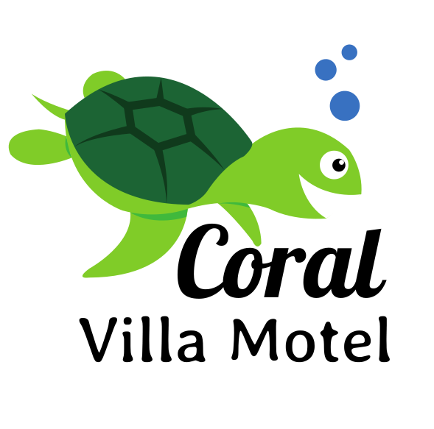

56 Takalvan Street, Svensson Heights, Bundaberg QLD 4670
Phone: 07 4152 4999 Phone: 0413 326 692
Email: info@coralvillamotel.com.au

Cancellation Policy:

Online Travel Agents (such as booking.com) - have their own cancellation policy which we uphold.

FLEX SMART – if you cancel any future night’s bookings, booking.com will organise a new guest or re-imburse us for the cancelled accommodation. No refunds are given until your booking.com dates are adjusted (due to the commission we pay them).

NON-REFUNDABLE – once you check in, your entire booking is non-refundable. This means if you cancel any of your future nights – there will be no refund

RISK FREE RESERVATIONS – once you check in, if you cancel any of your future nights, the 24 hours cancellation policy applies (meaning that Coral Villa Motor Inn requires 24 hours’ notice). No refunds are given until your booking.com dates are adjusted (due to the commission we pay them).

STANDARD RATE - once you check in, if you cancel any of your future nights, the 24 hour cancellation policy applies (meaning that Coral Villa Motor Inn requires 24 hours’ notice). No refunds are given until your booking.com dates are adjusted (due to the commission we pay them).

Direct Bookings (such as telephone, email) – 48 hours are required for cancellation of your booking from date of check in. If cancellation is less than 48 hours’ notice from date of check in, 2 night’s accommodation tariffs will be charged.

After check-in - If any booked dates are cancelled after check-in, 24 hours’ notice is required.

Public Holidays - are non-refundable and are to be paid when booking is made.

